The bank’s dataset includes data on 5000 customers. The data include customer demographic information (Age, Income, etc.), customer response to the last personal loan campaign (Personal Loan), and the customer’s relationship with the bank (mortgage, securities account, etc.). Among these 5000 customers only 480 (= 9.6%) accepted the personal loan that was offered to them in a previous campaign. The bank wants to predict which customers will accept personal loans to direct marketing efforts towards those customers.
After obtaining summary statistics, I began building the model. For starting this project, I built a base model to start. Results can be found below.
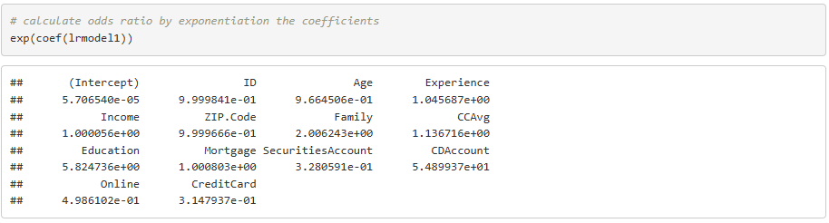
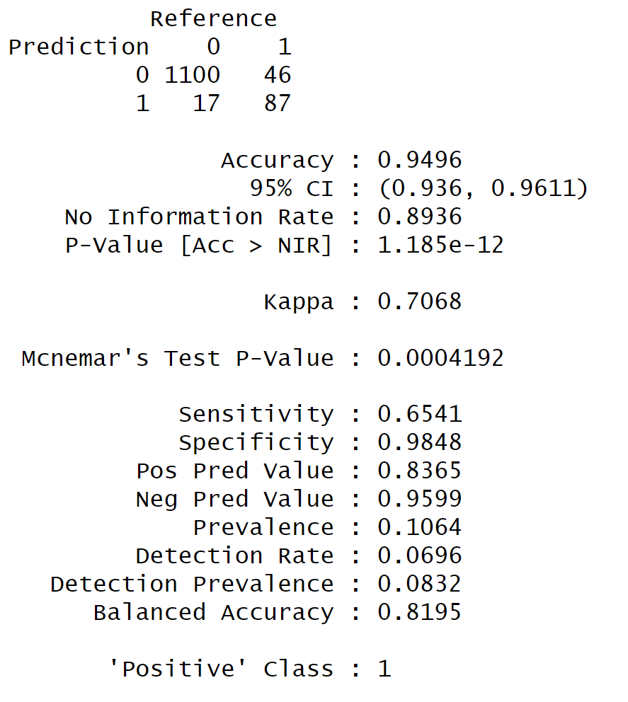
Regarding the first screenshot, the odds ratio is a measure of the odds of an event happening in one group compared to the odds of the same event happening in another group. The odds ratio can be calculated by exponentiation these value to get 1.000056 for Income which means we expect to see about 0.0056% increase in the odds of getting a personal loan, for a one-unit increase in income.
Total accuracy for this initial model is 0.9496 – that is, the total correct predictions divided by the total observations. This sounds like an accurate model; however, for logistic regression, there are other considerations. To start, the Universal Bank dataset is imbalanced. As mentioned previously, only 9.6% of this dataset represents true positives. As a result, it is easy to build a model with high accuracy without providing any business value.
To account for the imbalanced data, I used synthetic minority oversampling technique (SMOTE) and rebuilt the model. Refer below to view the output.
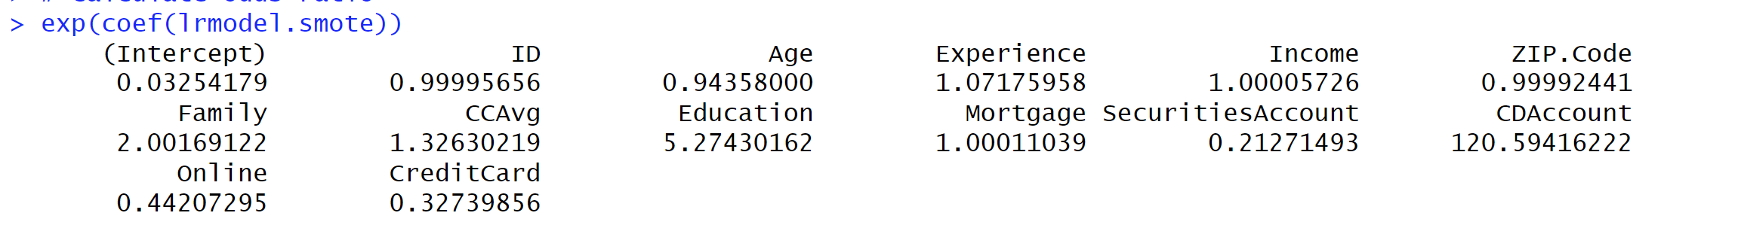
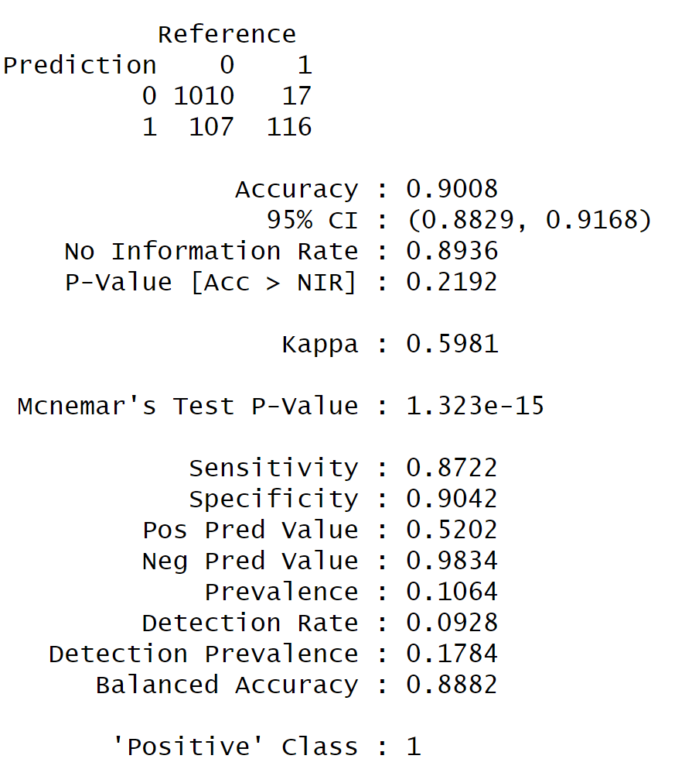
Instead of just duplicating minority class examples, which can lead to overfitting), SMOTE serves several purposes: first, finds nearest neighbors for each minority class sample; second, generates new synthetic points by interpolating between the minority sample and one of its neighbors; and lastly, adds those new points to the dataset to balance the class distribution.
Accuracy dropped for the model using SMOTE; however, this is to be expected. Sensitivity and specificity increased substantially (See: table below).
Model | Accuracy | Sensitivity | Specificity
Initial Model | 0.9496 | 0.6541 | 0.9848
SMOTE Model | 0.9008 | 0.8722 | 0.9042

Sensitivity (recall/true positive rate) indicates that the percentage of actual positives that are identified correctly; specificity indicates the percentage of actual negatives that are correctly identified. Both of these metrics increasing means that my model is correctly identifying true positives and true negatives more correctly now. Additionally recall increased from 65.4% to 87.2%, indicating that the SMOTE model catches more true positives, but makes more false positives as well since precision was lowered (83.7% to 52.0%).
Overall, to obtain the final result, I would perform feature selection and cross validation next to further improve performance. START HERE WHEN I COME BACK

